Communications-based train control

CBTC

**Introduction**

**CBTC** is a system use communications between train and track equipment to get a live information about the train such as location and speed .

IEEE defines CBTC as a continuous automatic train control system utilising

• High-resolution train location determination, independent of track circuits

• Continuous, high-capacity, two-way train-to-trackside data communications

• Trainborne and trackside processors capable of performing essential functions

**System architecture**

The system is divided to three sections

**1- tags or beacons :**

Tags or beacons are installed along the track , they define the current location of the train . tachometer installed on the axles count how far the train from the tags .

**2- Train unit :**

The train unit will receive the ID of tag and the distance between the train and the tag through the tachometer

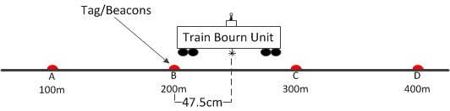

**3- wayside unit :**

After the train unit know the current location , it send the information to access point and then to wayside unit

Every access point has a range , once the train will be out of the range , it will disconnect from the access point and connect with the new other access point

The way side units connected together through a network

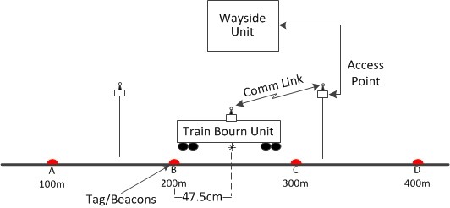

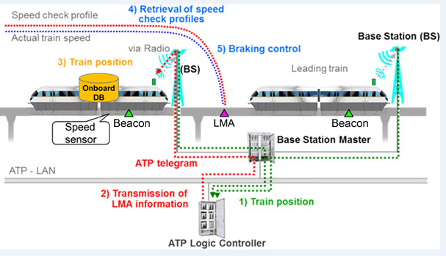

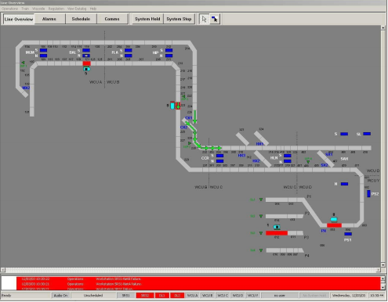

References :

<https://www.smartrailworld.com/expert-focus-what-is-communication-based-train-control-cbtc>

<http://www.hitachi-rail.com/products/signalling/cbtc/index.html>

<https://en.wikipedia.org/wiki/Communications-based_train_control>

<https://www.researchgate.net/publication/283187607_CBTC_Simulation_Platform_Design_and_Study/download>